Cognition-Centered Warfare: Operational Concepts for Complex Warfare

Source: Military Digest

2023-11-09

<http://www.81it.com/2023/1109/14685.html>



      Complexity science is one of the frontier areas of contemporary scientific development and a new tool for understanding, comprehending and exploring war phenomena, laws and mechanisms. As the form of war evolves from information warfare to intelligent warfare, the complexity of war is growing exponentially. It is becoming increasingly difficult to seize information control. The key to combat is to put the enemy in a "decision-making dilemma" so that even if it has information advantages, it cannot make correct decisions and thus loses its combat advantage. The focus of combat will shift from "information-centered" to "cognition-centered", and the winning mechanism will shift from "information-based winning" to "cognition-based winning".

**“Three Changes” Reveal the Reasons for the Increase of War Complexity**

War is a field full of possibilities, and change is its basic characteristic throughout. President Xi stressed that we must keep a close eye on changes in science and technology, changes in war, and changes in opponents. Changes in science and technology are the foundation, changes in war are the main body, and changes in opponents are the key. Changes in science and technology trigger changes in war, and changes in war prompt changes in opponents. The "three changes" have led to the evolution of war forms, the expansion of war fields, the transformation of war goals, and the expansion of war impacts, revealing the driving force behind the growth of war complexity.

**The change of science and technology subverts the basis for winning wars.** Science and technology are the core combat power and the most active and revolutionary factor in military development. Looking at the history of world military development, every major scientific and technological innovation has opened a new military revolution, and every military revolution has pushed military development into a new era. Scientific and technological innovation has become a huge engine for improving the combat effectiveness of the army. At present, a new round of scientific and technological revolution and military revolution is accelerating, the degree of informatization of modern warfare is constantly improving, and the characteristics of intelligence are becoming increasingly apparent, which has become more and more prominent in driving the military revolution. The rapid development of some cutting-edge technologies may fundamentally change the face and rules of war. The military game between major powers is more reflected in technical subversion and counter-subversion, raids and counter-raids, offsets and counter-offsets. The US Navy's "Nemesis" project includes reconnaissance, decoys, jamming and other systems. The decoy systems cover air, surface and underwater. Under the dispatch and command of distributed artificial intelligence engines, they can complement each other and cooperate in deception, creating a real "ghost aircraft carrier formation", which completely subverts traditional electronic deception methods and elevates information deception to an unprecedented level. It can be said that science and technology have never had such a profound impact on national security and the overall military strategy as it does today. It has profoundly intervened in, supported, and dominated the evolution of war forms and innovation of combat styles, and even subverted the mechanism of winning wars.

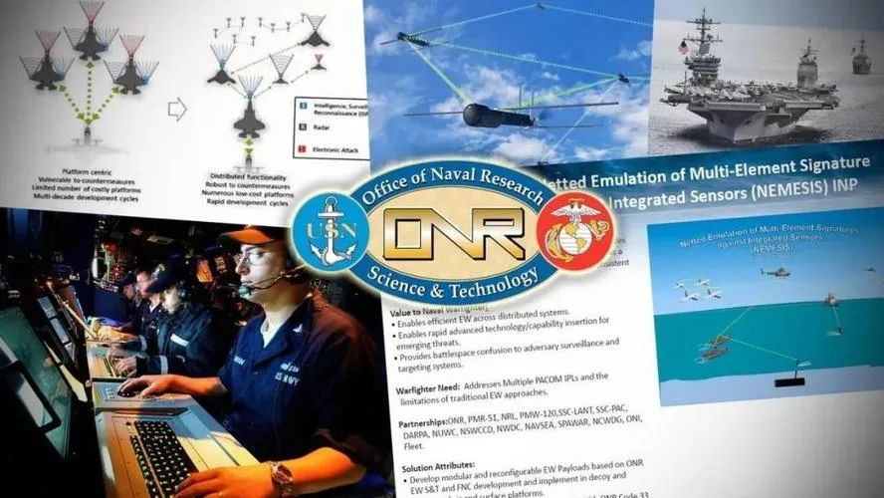

The US Navy's Nemesis project is based on networked collaborative electronic warfare

concept, integrating different systems and utilizing unmanned distributed

Clusters of electronic warfare platforms enable large-scale coordinated electronic warfare

**The changes in war highlight the complexity of war.** Modern warfare is undergoing profound changes, showing unprecedented diversity and complexity. This super complexity stems from many reasons: first, various advanced technologies or weapons continue to emerge, bringing many uncertainties; second, the battlefield covers multiple fields such as land, sea, air, space, network, electricity and cognition; third, a variety of combat targets, combat styles, combat fields, and combat methods are cross-related and combined to form a complex "hybrid war"; fourth, artificial intelligence algorithms construct a large number of combat elements into a complex logic, and promote the combination, deconstruction, and recombination of various elements at a machine speed that human thinking cannot match. In the Ukrainian crisis in 2022, on the surface, it was a confrontation between Russia and Ukraine, but in essence it was a "hybrid war" between the United States and Western countries and Russia; the Russian and Ukrainian armies widely used military and civilian drones to expand the "unmanned +" application mode, showing the prototype of future unmanned intelligent combat; with the support of the US NATO air and space situation intelligence, the Ukrainian army frequently used low-cost unmanned equipment to carry out raids on important Russian weapon platforms, highlighting the asymmetric attack advantage of new combat forces over large weapons and equipment of traditional combat systems. Changes in science and technology will eventually lead to changes in warfare. The impact of a single factor on war will become increasingly weaker, and the joint combat system composed of multiple factors will have a complex impact on war. The complexity of war, such as non-linearity, uncertainty, chaos, openness, adaptability, and confrontation, will show an exponential growth trend, which will make it more difficult for people to perceive and judge the progress and outcome of the war.

**Changes in opponents accelerate the growth of war complexity.** Changes in wars prompt changes in opponents. At present, we are experiencing a major change that has not been seen in a century. Major military powers are actively making strategic adjustments and promoting a new round of military reforms, showing the following characteristics: First, the trend of joint, miniaturized and autonomous systems is more obvious; second, weapons and equipment are showing a trend of digitalization, precision, stealth, unmanned and intelligent development; third, the combat form is developing towards "four non-contact, non-linear, asymmetric and irregular" and "three no" (invisible, silent and unmanned) combat; fourth, the military command form is developing towards flat, automated, networked and seamless. The United States regards China as its most important strategic opponent and has tried its best to suppress and contain China. It has vigorously strengthened the innovation of combat concepts and has successively proposed new combat concepts such as "hybrid warfare", "multi-domain warfare" and "mosaic warfare", claiming to fight a high-end war that will make the opponent "unable to understand the technology, difficult to predict the strikes, and unable to keep up with the speed". The core of the U.S. military's "Mosaic Warfare" is unmanned, low-cost, fast, lethal, flexible, and reconfigurable. It is based on distributed situational awareness, with the help of intelligent decision-making assistance tools, and draws on the concept of building blocks and jigsaw puzzles to adaptively formulate mission plans, dynamically reorganize combat forces, and decompose the functions of combat platforms into more nodes with single functions. A large number of functional nodes build a combat system. Replace the "kill chain" with a "kill net", and the combat system can be adaptively reorganized if several nodes fail or are missing.

**The growing complexity of war drives the transformation of war-winning mechanisms**

With the rapid development of national defense science and technology, the upgrading of weapons and equipment, and the rapid evolution of war forms, modern warfare has shown exponential and explosive complex changes. These changes may seem dazzling, but there are rules behind them. The fundamental reason is that the winning mechanism of war has changed. Only by understanding the winning mechanism of modern warfare can we accurately identify changes, respond scientifically, be good at seeking changes, and firmly grasp the initiative in future wars.

**The war form has changed from cold weapon war to intelligent war** . The war form is a holistic understanding of war. So far, the human war form has roughly experienced four historical stages: cold weapon war, hot weapon war, mechanized war, and information war, and is moving towards intelligent war. The history of cognitive warfare is almost as long as the history of human warfare. In the era of cold weapon war, hot weapon war, and mechanized war, cognitive warfare appeared more in the form of public opinion warfare and psychological warfare. As humans enter the information age, the development of cyberspace technology has greatly expanded the space of cognitive warfare, enriched the war technology means of cognitive warfare, greatly enhanced the penetration, timeliness, and deterrence of cognitive warfare, and unprecedentedly improved the status and role of cognitive warfare. In the future, the war form will enter intelligent warfare, and a large number of intelligent weapon systems and platforms will be equipped with the army and put into combat. Cognitive warfare can not only interfere with and deceive the cognition of enemy personnel, but also attack the cognition of intelligent equipment through algorithm deception means such as "adversarial input" and "data poisoning". Its application scenarios and scope will be further expanded, and its status and role will be further improved.

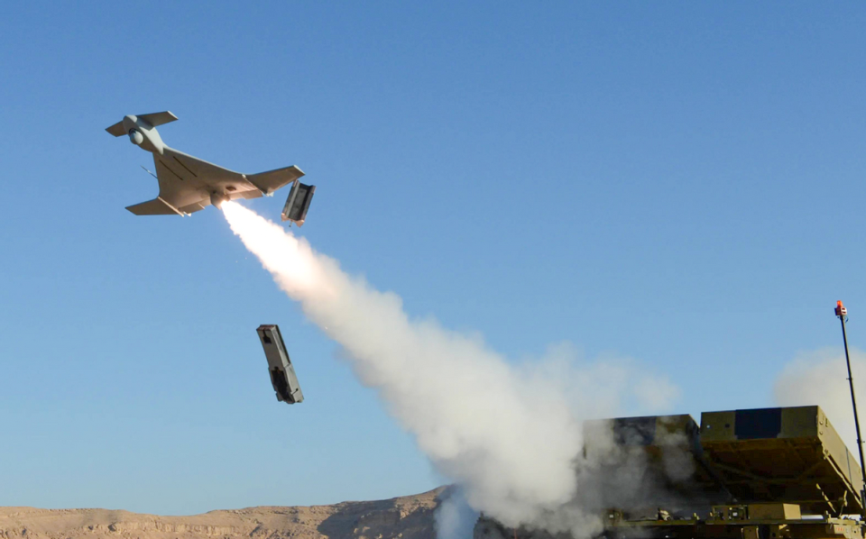

Drones are gradually becoming the protagonists of war.

The complexity of operations has further increased

**The purpose of war has shifted from military conquest to spiritual conquest.** The winning mechanism of modern warfare has changed greatly compared with the past. The violence of war has been curbed. The purpose of warfare has changed from the original siege and annihilation of the enemy's living forces to making the enemy obey one's will. The means of warfare have shifted from military conquest to more psychological and spiritual conquest, which has made the status and role of cognitive warfare increasingly prominent in modern warfare. In recent years, "hybrid warfare" has become a major means of competition among major powers. More and more countries have begun to focus on using new fields and new means to achieve political, military and economic goals that are difficult to achieve with traditional warfare. "Hybrid warfare" is a mixture of war subjects such as states, non-state actors and individuals, a mixture of conventional warfare, unconventional warfare and other war styles, a mixture of military operations such as combat, stability maintenance and reconstruction, a mixture of multiple fields such as politics, military, economy and people's livelihood, and a mixture of multiple combat objectives such as defeating the enemy and winning the hearts of the people. This is highly consistent with cognitive warfare. The combat field of "hybrid warfare" has expanded from the military field to the political, economic, cultural, and people's livelihood fields; the combat methods have expanded from firepower warfare and troop warfare to diplomatic warfare, economic warfare, network warfare, psychological warfare, public opinion warfare and other directions. This is highly consistent with cognitive warfare. The core essence is "profiting from chaos", the main purpose is to win people's hearts and minds, and the combat guidance is to win by cleverness.

**The domain of victory in war has shifted from the physical domain and the information domain to the cognitive domain.** Modern warfare occurs simultaneously in the three domains of physics, information, and cognition. The physical domain and the information domain are separated from the material domain, and the cognitive domain is separated from the spiritual domain. The physical domain is the traditional domain of warfare, consisting of combat platforms and military facilities, which provide the material basis for information warfare. The information domain is a newly emerging domain of warfare, that is, the space for information generation, transmission, and sharing, and is the focus of information warfare. The cognitive domain is the scope and domain involved in human cognitive activities. It is not only the space for human sensation, perception, memory, and thinking activities, but also the space for knowledge generation, exchange, association, storage, and application, as well as the space for perception, judgment, decision-making, and command and control in combat activities. The cognitive domain exists in the consciousness of combatants, affects their judgment and decision-making, and is an emerging domain of warfare. With the development of technologies such as network information and artificial intelligence, the scope of the cognitive domain has been greatly expanded, and is expanding from the human consciousness domain to the modern cognitive tools and artificial intelligence domain. The development of military technology has expanded the scope of the cognitive domain, providing more advanced, faster, and more effective material and technological means for cognitive warfare, greatly enhancing the penetration, timeliness, and deterrence of cognitive warfare, and fundamentally changing cognitive warfare, making the cognitive domain a new winning domain beyond the physical domain and information domain, and the ultimate domain of great power games and military confrontation.

**The winning mechanism of war has shifted from information winning to cognitive winning.** War confrontation is ultimately a cognitive game and confrontation. Mastering cognitive control means mastering the initiative in war to a large extent. Losing cognitive control will put you in a passive position in the war. Obtaining higher and stronger cognitive control is the key to defeating a strong enemy. Finding ways to master cognitive control and then seize comprehensive battlefield control, so as to achieve the greatest victory at the lowest cost, is an important mechanism and internal law of modern warfare, especially cognitive warfare. In recent years, the US military has successively proposed new concepts of future warfare represented by "decision-making center warfare" and "mosaic warfare", intending to use complexity as a weapon to create multiple dilemmas for opponents, requiring that while ensuring its own tactical "selection advantage", it creates a high-complexity decision-making influence on the enemy, interferes with its decision-making ability, and achieves a subversive advantage over the enemy in the cognitive domain. In the primary and intermediate stages of information warfare, the key to combat is to seize network control and information control, which runs through the progressive model of "network advantage → information advantage → decision-making advantage → combat advantage". As information warfare enters an advanced stage, it becomes increasingly difficult to seize control of information. The key to combat is to put the enemy into a "decision-making dilemma" so that even if it has information advantages, it cannot make correct decisions, thus losing its combat advantage. Only by having cognitive advantages can you have combat advantages. In future wars, cognitive advantages are the most important strategic advantages, and cognitive confrontation is the main form of confrontation. It can be said that "there is no war without cognition."

**Coping with complex warfare gives rise to the concept of cognitive-centric warfare**

In order to cope with the exponential growth trend of the complexity of modern warfare, we must apply the theories and methods of complexity science, change the concept of platform-centered warfare with firepower first and killing as king, and establish a cognition-centered combat concept. Cognition-centered warfare refers to a new combat concept that takes the cognitive domain as the winning field and seizes cognitive advantages as the combat goal, and focuses on interfering with cognitive means, suppressing cognitive channels, and influencing cognitive generation, interfering with, suppressing, deceiving and inducing the cognition of enemy personnel and intelligent equipment, and obtaining combat advantages by seizing and maintaining cognitive advantages. Its main winning mechanisms are as follows.



The Art of War by Sun Tzu states that “there is no constant state of warfare.

Water has no fixed shape; those who can adapt to the changes of the enemy and win are called gods.

**Destroy the enemy's will to fight with cyber deterrence.** Target the enemy's contradictions and weaknesses in politics, economy, military, diplomacy, and culture, spread deterrent information through cyberspace, or release information such as military parades, large-scale military exercises, and the development of new weapons and equipment through the Internet, so as to cause great fear and shock to the opponent's cognition and psychology, and deter the enemy from implementing actions that are not conducive to us. Comprehensively use network and electronic attack methods to carry out acupuncture strikes and warning attacks on important network and electronic targets and key core nodes of the enemy, destroy the enemy's system combat capability, affect the normal performance of the enemy's weapons and equipment, and implement psychological deterrence on the enemy. The US military's "gray zone warfare" theory is to rely on its own technological advantages and mainly take actions such as network and electronic countermeasures to respond to the opponent's "gray zone provocations", deterring the opponent from either giving up "confrontation" or escalating the conflict, putting it in a dilemma.

**Use information deception to induce the enemy to make wrong judgments.** Target the enemy's reconnaissance equipment, intelligence agencies and command systems, conceal one's own military intentions, military operations and military targets through cyber attacks, electronic deception and other means, transmit to the enemy information about one's own erroneous and false combat intentions, troop configurations, combat capabilities, combat plans and battlefield situations, or send false orders and information through the enemy's command information system, so as to induce the enemy to make wrong judgments and disrupt the enemy's combat command. Implement new types of attacks such as "adversarial input" and "data poisoning" against artificial intelligence algorithms, so that they can obtain our preset conclusions through deep learning training, or make them fall into local optimal solutions and ignore the global optimal solution. Use computer imaging, video synthesis, virtual reality and artificial intelligence technologies to synthesize sound, video, images, text information, etc., or use "deep fake" technology to generate false information that is indistinguishable from the real and true, and spread it in large quantities through the Internet to confuse and deceive the opponent and affect its decision-making and actions.

**Use information suppression to block the enemy's cognitive means.** Use "soft" and "hard" attack methods to destroy the enemy's important network targets, as well as core routers, switches, gateways, key servers, etc., to destroy their network nodes. In view of the networking characteristics of wireless links such as the enemy's command and control network, communication transmission network, weapon hinge network and early warning detection network, a comprehensive use of electronic interference, GPS spoofing attacks, command and control link takeover, data hijacking control and other technologies and means to suppress their data communications, block their communication links, and interfere with their combat command. Carry out network and electrical paralysis attacks on the enemy's command and control, military communications, early warning detection, aerospace information and other military networks, destroy and paralyze the core networks that affect their operations, and weaken their combat capabilities.

**Use propaganda to create a favorable public opinion environment** . Cooperate with the country's political, military, and diplomatic struggles, vigorously publicize the justice of one's own side in the war, and inspire the enthusiasm of all the people to fully support the war. With the help of instant messaging tools, online forums, podcasts, Twitter, WeChat and other new media platforms, systematically spread information to attack the enemy's weaknesses, gain widespread attention and general resonance, and then report and create new hot spots at the right time, repeatedly build momentum to enhance the influence, and form a resonance effect to expand the effect. Through cleverly setting the agenda to "set the tone" for propaganda, through strong media to build public opinion momentum, set off a "spiral of silence", control and guide public opinion, and change people's views and behaviors.

**Use psychological attacks to disintegrate the morale of the enemy's military and civilians.** Through the Internet, widely disseminate processed and processed information, publicize the justice of one's own side, demonstrate one's own strength, will and determination, vilify the enemy politically and morally, unite the thoughts and will of the military and civilians internally, strive for the commanding heights of legal and moral principles externally, and "soften" and "weaken" the enemy spiritually. Use a variety of network communication methods and technical means to send various deceptive, disruptive, inducing, and deterrent information to the enemy's military and civilians in a targeted manner, attack the enemy's psychological defense line, and encourage them to have an ineffective mentality of confrontation, thereby losing their combat capability. Create momentum, guide momentum, plan momentum, build momentum, and expand momentum through the Internet to create a "momentum" that is beneficial to oneself but not to the enemy, causing psychological shock to the enemy's people, thereby affecting or changing their psychological state and implementing effective psychological attacks.

**Use legal struggle to gain legal and moral support.** Use legal weapons to curb the enemy's possible or future illegal acts, declare the legality of our actions, affirm our right to military counterattack, and declare our firmness in pursuing war responsibilities, so as to deter the enemy. By exposing the illegality of the enemy's provocative behavior, criticizing the legal basis of the enemy's combat operations, and condemning the enemy's illegal acts, we can cause the enemy's strategic defeat and our own strategic gain. Use legal means to restrict the enemy's possible actions, limit the possible interference of third parties, and block other parties from interfering with our actions. Formulate the laws and regulations required for our operations, provide legal protection for our actions, or take legal remedies to reduce the negative impact that may be incidental to our actions, and ensure that combat operations are carried out in accordance with the law.